Tutorial Linux

How Does it work?
Linux Works as a core(kernel) that manages hardware resources, such as CPU,memory and disk, and communicates with applications and the user interface.
Where can i download? How much does it cost?
You can download Linux distributions like Ubuntu and Linux Mint for free from their official websites and the cost is zero, as they are free and open sources operating systems.
The link is
https://linuxmint.com.br/downloads/ for Linux Mint and
the Ubuntu https://ubuntu.com/download/desktop
When were it created?
On August 25, 1991, this system was announced in a post on the Usernet newsgroup “comp.os.minix.”
Who is the creator/owner?
Linux was created by Linus Torvalds, a Finnish software engineer,
and is an open-source project maintained by a global community of developers and companies. Torvalds owns the Linux trademark, but anyone can create and distribute Linux distributions, which are generally licensed under the GNU General Public License.
What are the requirements?

Hardware Requirements
Linux requirements vary significantly between distributions, but typically include a 1 GHz dual-core processor, 1 GB of RAM, and 8 GB of disk space for lighter distributions, while Ubuntu may require 2 GB of RAM and 25 GB of disk space. Higher hardware recommendations, such as 4 GB of RAM and 50 GB of disk space, are for more comfortable performance.

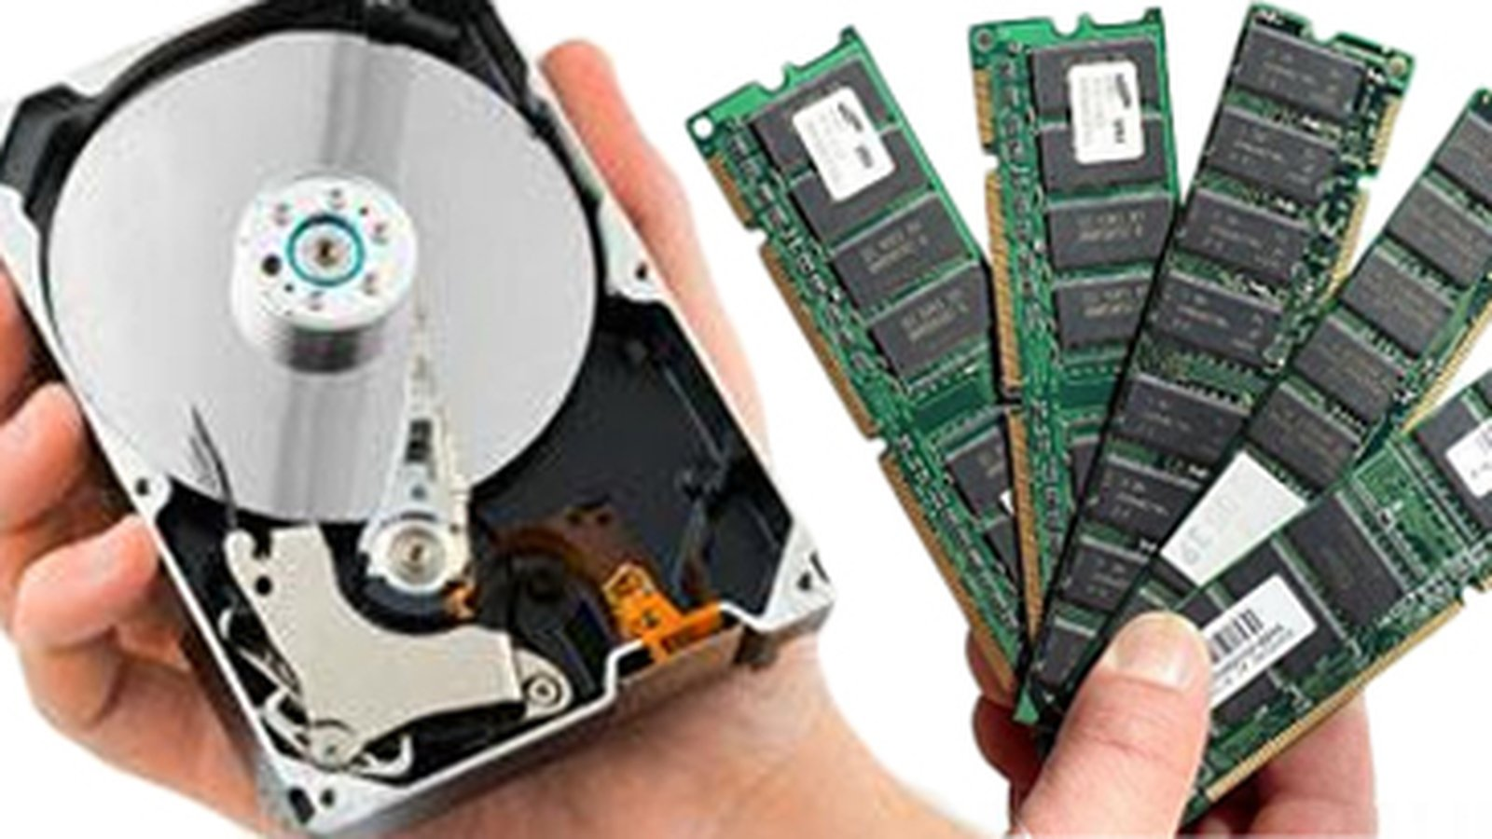
Interface for Linux Ubuntu
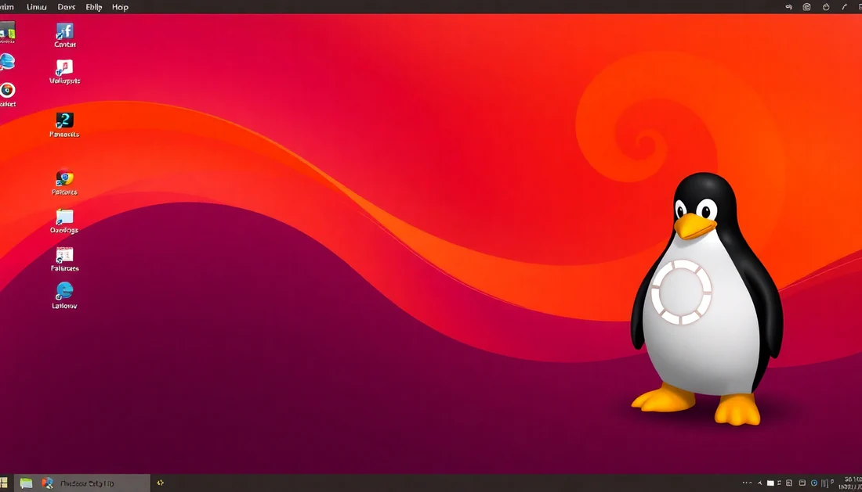

Why is it important in information Technology?
Linux is widely used by IT professionals to manage various types of systems on computers, servers, mobile phones, and other devices. Linux allows users greater flexibility. Its updates are made constantly, and the system has numerous configuration options, as well as several programs developed exclusively for Linux.

Fonts:
https://www.ibm.com/br-pt/think/topics/linux
https://pt.wikipedia.org/wiki/Hist%C3%B3ria_do_Linux
https://sempreupdate.com.br/requisitos-de-sistema-do-ubuntu-linux/#:~:text=Requisitos%20de%20sistema%20do%20Ubuntu%2020.04%20LTS%20ou%20Ubuntu%2020.10,Acesso%20%C3%A0%20Internet%20%C3%A9%20importante

